

DEPARTMENT Of ZOOLOGY

OVERVIEW OF THE DEPARTMENT

The department of Zoology is a vibrant academic unit dedicated to the study of animal life. Established with a vision to promote excellence in education and research in animal science, the department has continually evolved to meet modern scientific and societal needs. It offers under graduate programmers designed to equip students with comprehensive knowledge of animal diversity, physiology, behavior, ecology, biotechnology and cell biology.
- VISION :
To be a center of excellence in zoological education fostering innovation, conservation and sustainable interaction with animal world.

- MISSION :
- To impart quality education in animal science through dynamic teaching and hands on experience.
- To conduct cutting edge research in various fields of zoology.
- To promote awareness and responsibility toward biodiversity conservation
- To develop skilled professionals and researchers who contribute to society and science.

- COURSES OFFERED :
- B.Scs. [BZC] [Botany, Zoology, Chemistry].

- CAREER OPPORTUNITIES FOR GRADUATES:
- Higher studies (M.sc)
- Competitive exams (CUET, UPSC, GROUPS, SSC).
- Employment in teaching, scientific labs, public sector.

- FACULTY :

POKURI USHA RANI M.Sc., B. ED, UGC-NET, TS-SET

- EDUCATIONAL QUALIFICATION :
- She has completed for M.SC Zoology with medical entomology specialization in 2020 from university college of sciences, Hyderabad Osmania University.
- She has qualified lectureship [NET] in 2022 conducted by joint UGC.
- She has qualified TS-SET in 2023 conducted by Osmania University in the subject life sciences.
- She is pursuing her PhD from Osmania University.

- Predecessor M. SUPRAJA
• She has completed her M.Sc. from Kakatiya university Hanamkonda.

- Teaching interests:
- Animal taxonomy and systematics
- Cell and molecular biology
- Genetics and evolution
- Physiology and biochemistry
- Ecology and environmental biology.
- Entomology

- Career opportunities
Graduates from the department pursue careers in:
• Academia and research
• Civil services and public sector jobs
• Education and Training

- INFRASTRUCTURE :
- Well experienced faculty.
- Seminar hall for guest lectures and workshops.
- Library resources specific to life sciences and zoology.
- Well-equipped zoology lab.
- Dedicated classrooms with modern teaching aids.
- Access to e-resources and research journals.

- ACTIVITIES :
- Department of zoology conducted:
- Poster presentation by students.

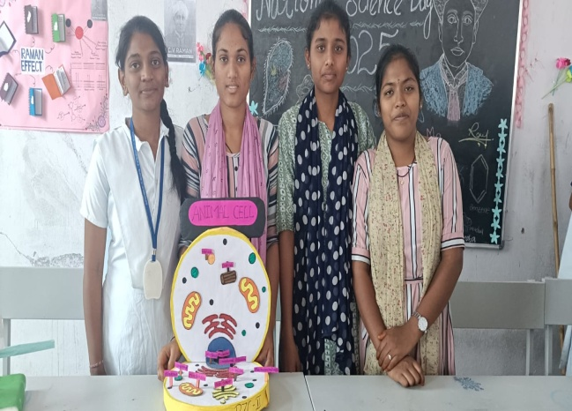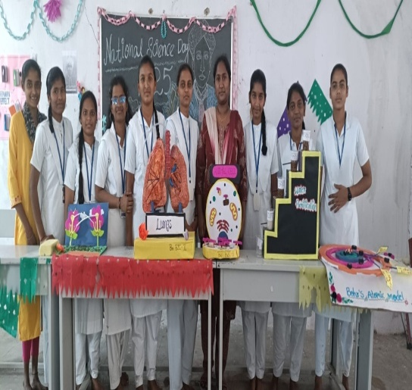
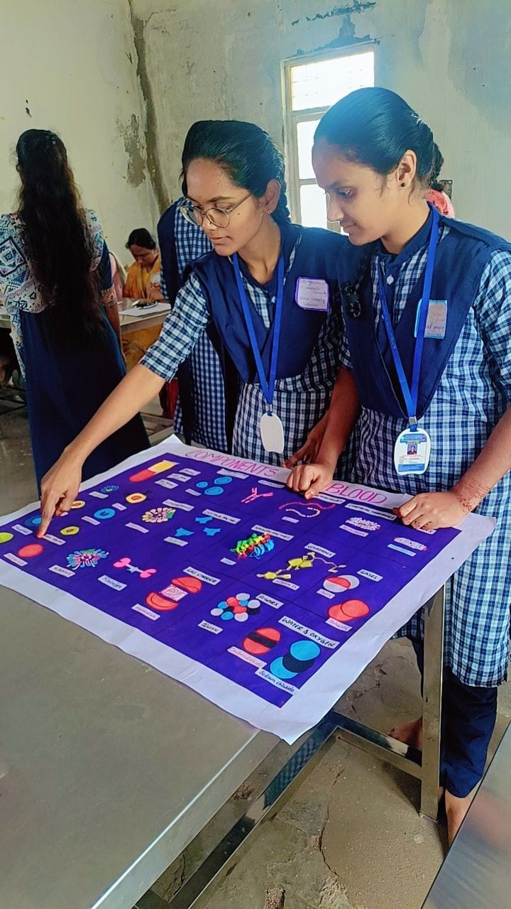
Conducted seminars by student

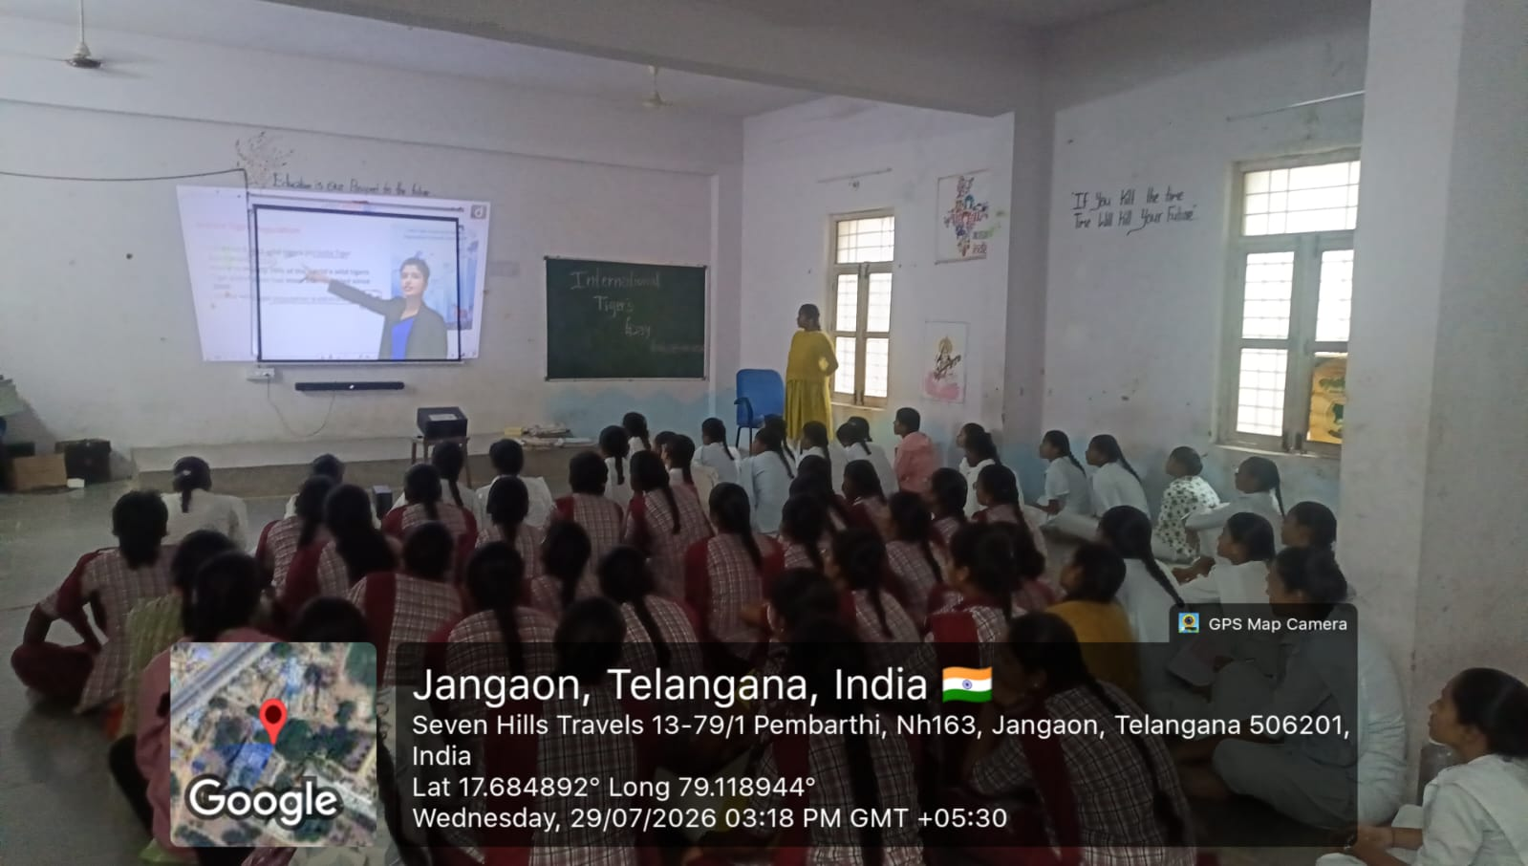

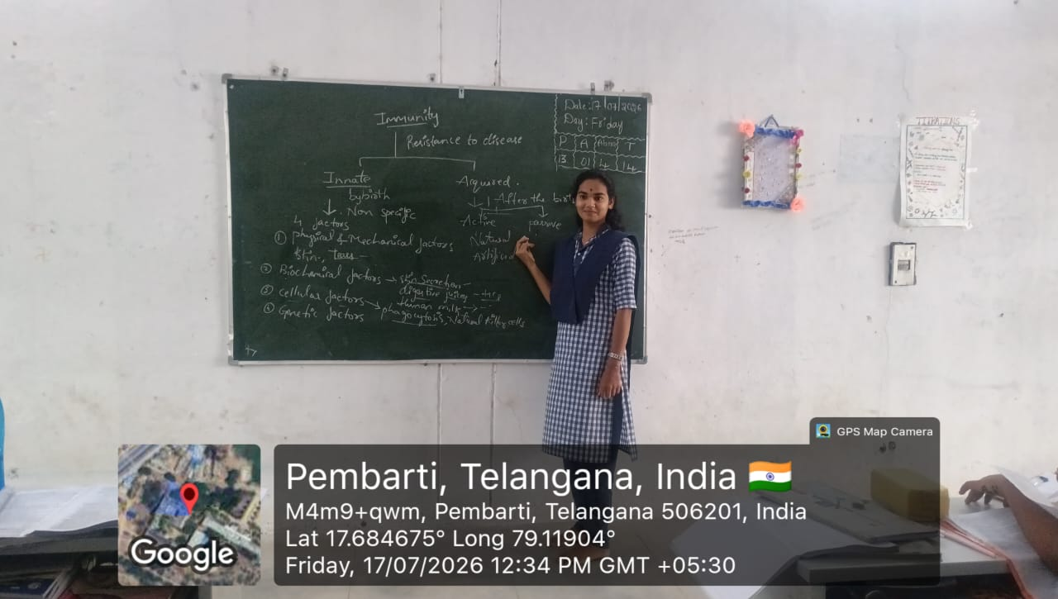

- Conducted blood grouping campaign.

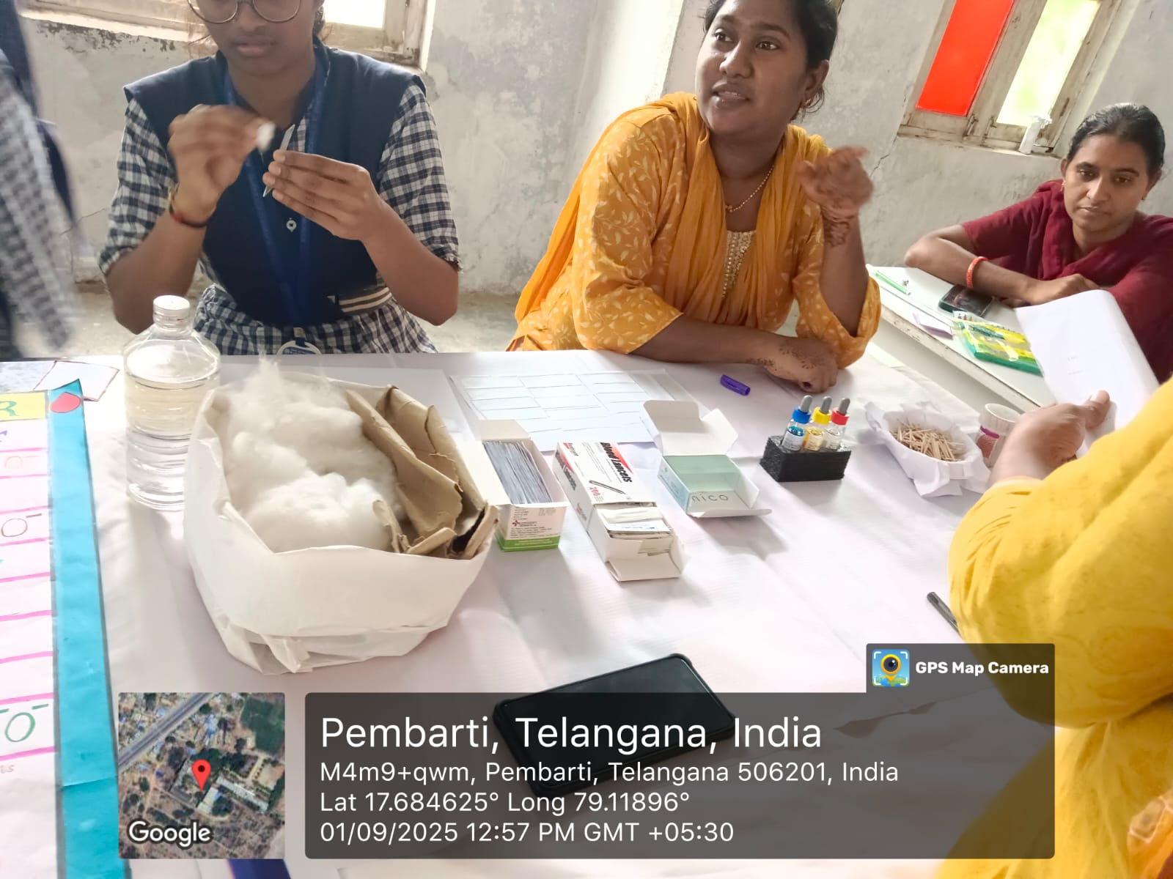

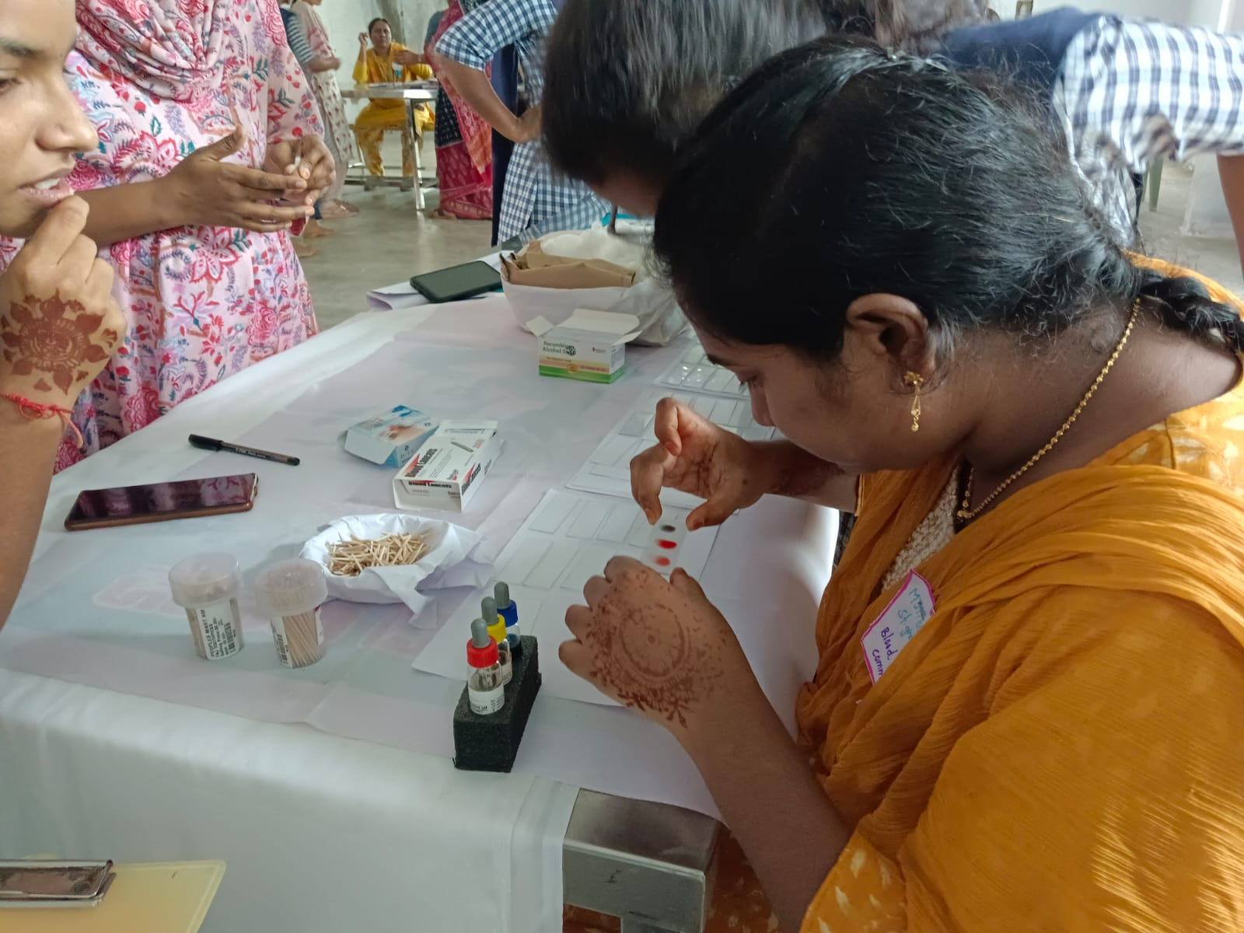

- Conducted Science day.

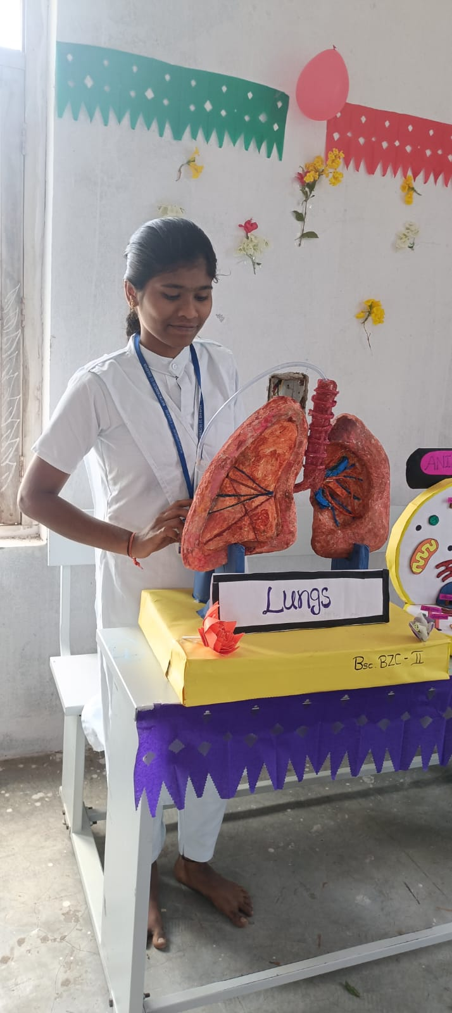
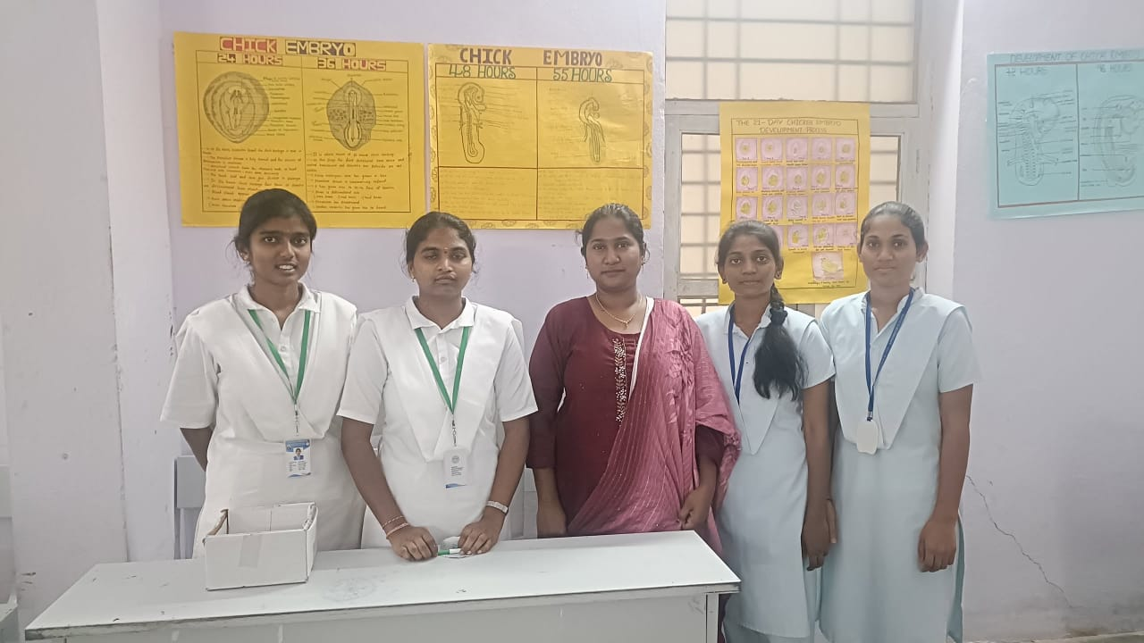

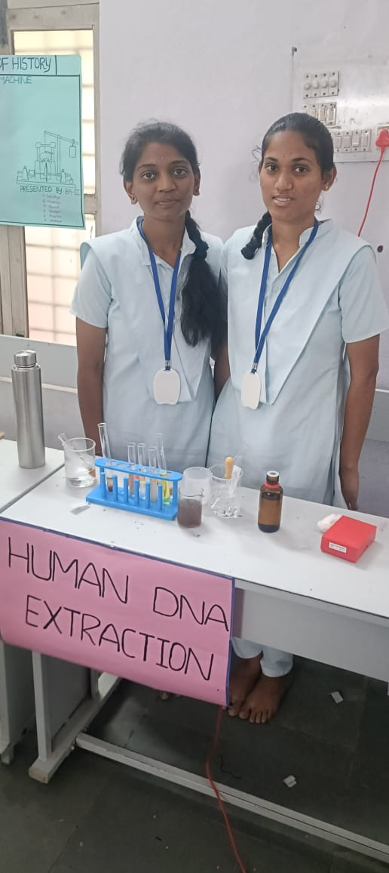
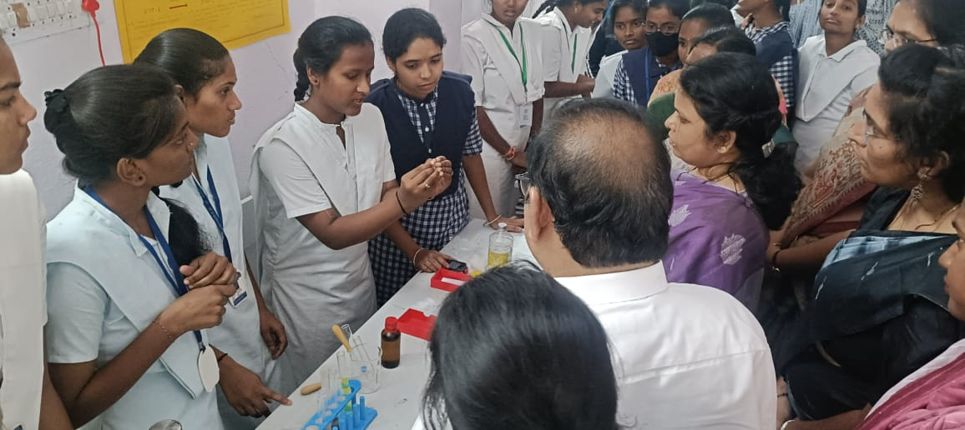

- TIME TABLE
DAY/TIME | 8:15-9:15 | 9:15-10:15 | 10:15-11:15 | 11:30-12:30 | 12:30-1:30 | 2:30-3:30 | 3:30-4:30
MONDAY |  | BZC-III | BZC-I |  |  | BZC-II LAB | AB B-II
TUESDAY | BZC-III | I-BZC |  | WRM | BZC-II | RCBZC-III
WEDNESDAY | BZC-III |  |  | BZC-II | RCBZC-I | BZC-II LAB B-I
THURSDAY |  | BZC -III LAB |  |  |  | BZC-I LAB B-II
FRIDAY |  |  | BZC-II | I-BZC | WRM RC BZC-II .
SATURDAY | BZC-II | BZC-III |  |  |  | BZC-I LAB B-I

RESULT ANALYSIS [2023-2024]
Group | Year | Semester | Appeared | Passed | Failed | Pass%
B.SC[BZC] | 1 | I | 31 | 31 | NIL | 100%
B.SC[BZC] | 1 | II | 29 | 29 | NIL | 100%
B.SC[BZC] | 2 | III | 31 | 31 | NIL | 100%
B.SC[BZC] | 2 | IV | 30 | 30 | NIL | 100%
 |  | TOTAL | 121 | 121 | NIL | 100%
RESULT ANALYSIS [2024-2025]
Group | Year | Semester | Appeared | Passed | Failed | Pass%
B.SC[BZC] | 1 | I | 16 | 16 | NIL | 100%
B.SC[BZC] | 1 | II | 16 | 16 | Nill | 100%
B.SC[BZC] | 2 | III | 28 | 28 | NIL | 100%
B.SC[BZC] | 2 | IV | 27 | 27 | Nill | 100%
B.SC[BZC] | 3 | V | 31 | 31 | NIL | 100%
B.SC[BZC] | 3 | VI | 31 | 31 | NIL | 100%
 |  | TOTAL | 149 | 149 | NIL | 100%

RESULT ANALYSIS [2025-2026]
Group | Year | Semester | Appeared | Passed | Failed | Pass%
B.SC[BZC] | 3 | V | 25 | 25 | Nill | 100%
B.SC[BZC] | 2 | III | 14 | 14 | Nill | 100%
B.SC[BZC] | 1 | I | 32 | 26 | 6 | 81.20%
 |  | TOTAL | 71 | 65 | 6 | 92%

RESULT ANALYSIS 2026-2027
Group | Year | Semester | Appeared | Passed | Failed | Pass%
B.SC[BZC] | 3 | VI | 25 | 25 | NIL | 100%
B.SC[BZC] | 2 | IV | 14 | 14 | Nill | 100%
B.SC[BZC] | 1 | II | 32 | 28 | 04 | 87.5%
 |  | TOTAL | 71 | 67 | 4 | 94%

- FUTURE PLANS :
- Establishment of a Research Centre.
- Introduction of Industry- collaborative courses. 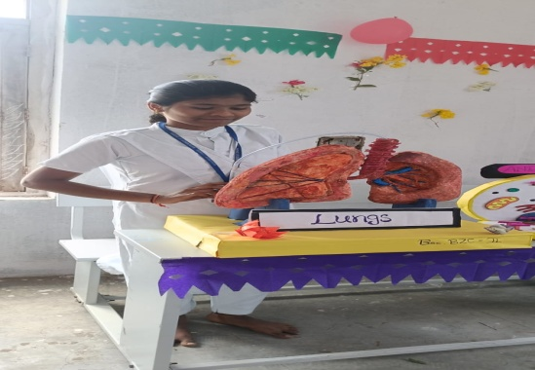
- Promote student research.

